Mark your calendars: Next LT meeting: Tuesday, February 14, 2017. 11:30 a.m. to 1:30 p.m. Check email for location.

Impact 100 Redwood Circle Leadership Team

Minutes

Tuesday, January 10, 2017; 11:30 a.m.-1:30 p.m.

Location: 3510 Unocal Place, Conference Room

Present:
Melissa Kelley, President
Suzy Marzalek, Treasurer
Susan Milstein, Secretary
Carol Newman, Internal Communications
Cindy Schmidt, Membership
Gayle Holste, Marketing and Education & Events
Judy Farrell, 2016 Community Grants Working Group
Carolyn Lynn Wood, 2016-17 Impact Grant
Jan Gilman, Liaison 2015-16 Impact Grant

Community Grants:
Melissa congratulated Judy Farrell and Shirley Ward and the members of the Community Grants Working Group for their “outstanding” work in fielding nominations, devising and reviewing grant applications, and overseeing the vote for our five $5,000 Community Grants in 2016. Judy said the experience was “a lot of fun” and “rewarding,” adding that it was “a pleasure and a joy to lead the group of 15 energetic women.” The Working Group’s members this week participated in an assessment of their experience. Judy said the assessment process, led by Sharon Keating, was extremely worthwhile. Sharon has already sent the assessment results to co-chairs Judy and Shirley. Judy said, “I can’t thank [Sharon] enough for offering her rich talents.”
Through the assessment process, the working group committed to four action items:
- recruit new members for next year’s Community Grants Committee, including co-chairs
- draft a document outlining the Working Group’s internal procedures to help next year’s Community Grants Committee (Sharon Robison will lead this effort.)
- collect data from Community Grants nominated nonprofits (Jennifer Cornell will head this up) and work with the Leadership Team (LT) and Membership Committee to survey our membership about the Community Grants
- develop a simple Community Grants Committee charter. (Ina offered to chair this effort.)
Judy said the consensus of the Community Grants Working Committee is that in 2017 the community grant recipients should be announced by early November to avoid overlapping with Thanksgiving. Discussion ensued about the need to coordinate and determine an annual organizational calendar that can be shared with all Impact 100 RC’s committees. Several LT members commented that some Impact 100 RC members were confused this year between the Community Grants and the Impact Grant, and didn’t realize which grants they were voting for in November. Next year’s calendar should attempt to avoid such confusion. Chairs of the E&E Committee, the Impact Grant 2017 Committee, and the Community Grants Working Group agreed to confer about the 2017 calendar this month, and to bring their ideas and recommendations to the LT meeting in February. Gayle offered to take the lead on organizing a meeting of the committee chairs.

E&E Committee:
Gayle provided an update on the agenda for the Feb. 8 membership meeting. VOICES will give a presentation as will the five Community Grant recipients. VOICES’ status report also will be included in our next newsletter for members who aren’t able to attend February membership meeting. Following the grant recipient presentations, Sharon Keating will facilitate Table Top discussions focusing on several key topics, including communication within our organization and member engagement, enjoyment, and continuation. Members are encouraged to show up for the social time at the beginning of the meeting to take advantage of the chance to talk with representatives from VOICES and from the organizations that received Community Grants. Members are invited to bring guests to the Feb. 8 meeting. As Gayle put it, “We’ve got plenty of room.”

Changing to Calendar Year:
The LT voted unanimously to conduct our financial management, reporting, and decision-making on a calendar year basis in the future instead of on a fiscal year basis, as we have been doing. The Executive Team’s (president, vice president, secretary, and treasurer) terms of service also will coincide with the calendar year from here on out.
Suzy recommended switching to the calendar year for our financial management, reporting, and decision-making because doing so will allow future treasurers of our organization to rely on the year-end reports of the Community Foundation to determine how much money we can commit in the next year to the Impact Grant and to the Community Grants. (Our prior situation of operating on a fiscal year basis while the Community Foundation operated on a calendar year basis led to much confusion and extra work, according to Suzy.) Prior to the vote, discussion ensued about the issue of members who join between January 1 and March 31. The LT decided that members who join between Jan. 1 and March 31 will be allowed to vote on that year’s Impact Grant while donations that come in after Jan. 1 will be reserved for the following year’s grant cycle.

Governance Committee and Nominating Committee.
The LT unanimously voted to accept the draft charter for Governance Committee presented by Suzy. (see the draft charter below)
Suzy is chairing the Governance Committee, and is now actively recruiting members. Once the Governance Committee completes its work, a Nominating Committee will be formed to begin its work in adopting a charter and moving ahead with its assignments in recruiting members to serve on the Leadership Team and on various committees. Several members have already expressed interest in serving on the Nominating Committee. Suzy invited those members to also participate on the Governance Committee, and they are considering her offer.
Discussion ensued about what the Nominating Committee’s role would be in recruiting committee chairs. The consensus of the LT was that the Nominating Committee would be responsible for putting together a slate of executive officers and also would be responsible for encouraging members to take on various leadership positions throughout the organization. Committee chairs will be selected by the committees themselves.

Assessments:
Sharon Keating has generously offered to help each committee conduct an assessment as she did for the Community Grants Working Group. The LT voted to encourage each committee to conduct an assessment and to conduct its own assessment. The LT will begin working on its own assessment soon after the May 6 membership meeting.

Draft Membership Letter:
The LT reviewed and suggested edits to a letter from the president to be sent to all members in the near future.

Impact Grant 2017:
Carol Lynn provided an update on the Impact Grant process. The deadline for submitting Letters of Intent (LOI) has passed, with 16 organizations submitting letters. (Down from 23 last year) The LOI will be reviewed and scored. Qualified applicants will have a month to submit their final proposals. The final list of applicants for the 2017 Impact Grant will be announced at the Feb. 8 meeting.
Carol Lynn said the committee would like next year’s calendar to allow more time to train committee members to review grants. Time was limited this year, and some reviewers felt they could have used more practice evaluating mock applications before starting the actual review work.

Our meeting was adjourned at 1:30 p.m.

Submitted by Susan Milstein
susan@personalhistoryproductions.com
707-322-1068

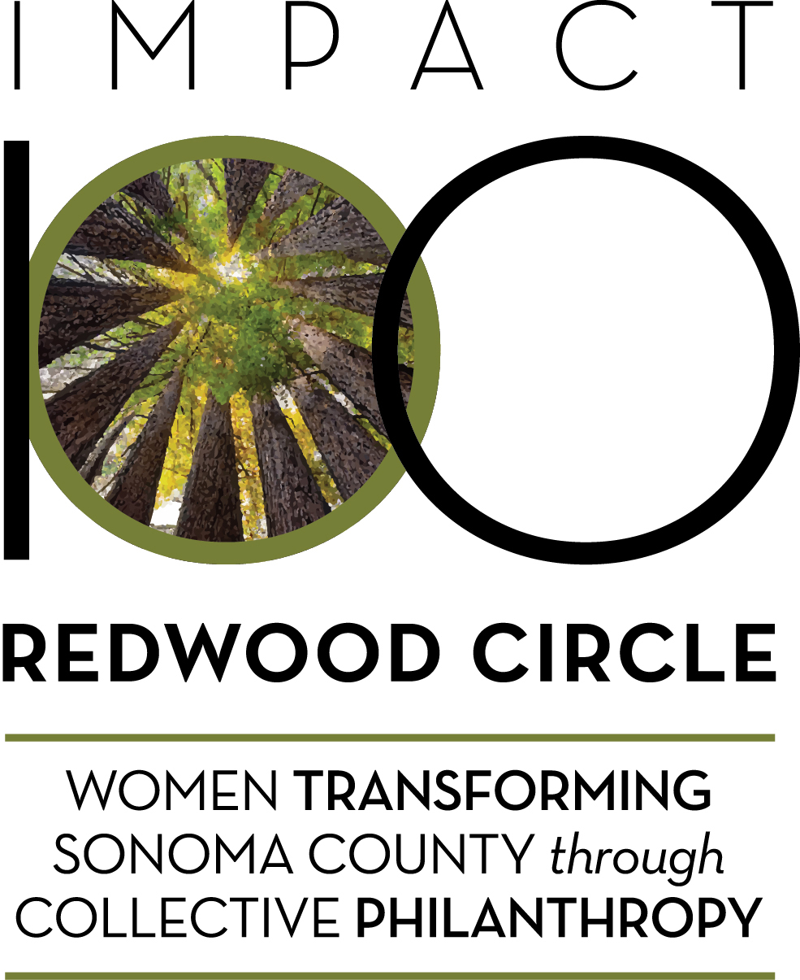
IMPACT 100 REDWOOD CIRCLE (RC)
DRAFT Governance Committee Charter

Committee Members for 2017: Chair: Suzy Marzalek Members TBD

Purpose (why this committee exists):
- Monitor how well Impact 100 RC is functioning, communicating, and living up to its objectives and aspirations (including the effectiveness of the Leadership Team).
- Ensure that policies, procedures, and roles for Impact 100 Redwood Circle (RC) are documented, monitored, and kept up to date; and that Impact 100 RC is operating in compliance with local, state, and federal laws.
- Ensure an annual Nominating Committee is formed to recommend a slate of Executive Committee members for approval by membership. Executive committee consists of President, Vice President, Treasurer and Secretary.

2017 Deliverables: (specific goals/work of the committee)
- Create a formal Policies and Practices document [contents similar to a Bylaws document] and gain its approval by Leadership Team and/or membership.
- Identify organizational issues and provide recommendations to Leadership Team and/or membership on their resolution.
- Coordinate with Nominating Committee on the creation of the 2018 Executive Committee slate.
- Ensure annual Leadership Team self-assessment.

Chair Responsibilities:
- Ensure committee accomplishes deliverables and monitor progress against milestones
- Solicit ongoing input and feedback from committee members on the committee’s work
- Coordinate development of meeting agendas and necessary materials
- Facilitate committee meetings and manage participation of members
- Invite guests to participate as needed; brief them prior to meeting
- Clarify next steps and ensure follow-up of agreed on committee actions
- Ensure minutes are recorded and distributed in a timely manner
- Keep Leadership Team/membership informed about key actions/issues and solicit input as needed
- Conduct an assessment of committee effectiveness

Member Responsibilities and Expectations of Each Other:
- Attend meetings and come prepared to participate
- If cannot attend a meeting, inform Chair and provide input prior to meeting if possible
- Follow through on assignments in a timely manner
- Share information and educate others about specific issues
- Engage in spirited discussions, share different ideas and perspectives, explain the reasons behind your position/opinion, listen well to others, be open minded and curious
- Honor the sensitivity and possible confidentiality of committee discussions
- Agree to disagree at times, and once a committee decision has been made, support the decision and its rationale outside of the committee meetings
- Have fun!

Leadership Team Responsibilities:
- Provide overall guidance and direction related to scope and focus
- Promote, recognize and celebrate the committee’s work

Operating Agreements for Meetings:
- The group will meet bi-weekly during February thru April, then determine meeting frequency for May thru December – committee to discuss and decide.
- Agenda will go out one week in advance, minutes will be distributed within one week after each meeting
- Possible method for making decisions … committee to discuss whether they like this approach.
  - Decisions will be reached using a “polling process.” In a polling process, the committee chair will call for a poll on how people stand on a particular decision. If the polling demonstrates consensus (100%), the decision is achieved. If the polling indicates 80% or more, the individuals not agreeing are asked, “What will it take to get your buy-in”? The team then works to see if a decision can be reached that incorporates the dissenting vote(s) without compromising the issue. After this process occurs, a final polling is taken. A poll of 80% or more indicates approval of the decision. This recognizes that, at times, not everybody will agree but, that for a vast majority of the time, each individual will be fully represented by the decisions. Based on this approach, all members of the group agree to support the decisions of the group recognizing that there will be instances when they individually were not supportive of a specific decision.

